ACT Health Club Training/Rally Days Phase 1 commencing 22 May 2020.
Queanbeyan Rally day recommencement 14 June 2020 weather permitting
Date of Event: 14th June 2020 |  | Risk Management Team: Queanbeyan Pony Club
Risk | Risk Rating | Control / Actions | Person Responsible
Attendees to confirm and sign Covid-19 declaration which states that they are well and have not had contact with anyone with COVID-19 | 1 | - If rider and/or family members have been to Covid-19 affected areas, or been in contact with someone who has Covid-19 or shows symptoms of Covid-19 they may not attend and need to self-isolate for 14 days and unable to attend pony club until signed off by Doctor with a negative Covid-19 test result.  - Attendance at rally day by pre-registration only. Others turning up on the day will be asked to leave. | All Attendees  Safety Officer/Membership Secretary to collect  President
Contracting Covid-19 during travel to event – driving | 4 | Ensure that riders follow all guidelines produced by ACT Health https://www.covid19.act.gov.au/resources/canberra-recovery-plan  Members may also refer to additional information from NSW Health on how to protect yourself – see NSW Health website and recommendations below. | Secretary to distribute Covid-19 information to all attendee’s
Contracting Covid-19 – whilst at Pony Club | 4 | - PCA NSW have strict bio-security protocols in place for both riders and horses.  - All participants and support person/s attending grounds MUST complete Covid-19 declaration form and submit upon arrival – if participant and support person/s do not complete a form they must be asked to leave the grounds.  - Riders to follow all directions of Organising Committee  - Organising Committee will ensure that the venue has been cleaned prior to commencement maintained during the event  - Organising Committee to provide washing facilities and/or 60% alcohol based hand sanitizer  - Rider and other attendees to regularly wash hands/use hand sanitizer and social distance as per NSW Health regulations  - Riders and other attendees to follow all guidelines produced by NSW Heath on how to protect yourself – see below  - Minimise the use of equipment by riders/members or minimise the number of people setting up and packing down equipment to stop cross contamination.  - Place COVID posters in predominant places throughout venue. | - Instructors to brief riders/helpers on commencement on Covid requirements  - Allocated personnel for movement of equipment and cleaning prior and on completion  - Toilet facilities cleaned prior to commencement and on completion. Allocated to club member  - Secretary to provide hand sanitizer prior to commencement and monitor as required  - Self-monitoring – people must determine their own level of risk depending on their current health status  - Safety Officer to have posters on the day to be placed at venue
If rider has concerns of possible contraction of Covid-19 | 2 | Follow ACT Health (https://www.covid19.act.gov.au/resources ) And may refer to NSW Health update on how the virus is spread and how long does Covid-19 last on surfaces - riders should follow all directions of Organising Committees and follow all guidelines produced by ACT Health and in recognition of NSW Heath on how to protect yourself. | Self-monitoring – members must determine their own level of risk depending and their current health status
Gear Check – no contact to be made | 2 | - No contact by Gear Check Steward to rider or their equipment during Gear Check. Gear check to be completed instructor of group. Riders to be gear checked unmounted first so rider can show gear is suitable  - Rider (if old enough) or parent/responsible person to be on hand (one per rider only) during Gear Check to make any adjustments to gear as requested by Gear Check Steward | - Instructor  - Rider  - Parent/responsible adult
Contact between Instructors and rider – no contact to be made | 2 | - No contact by Instructor to rider or their horse during Rally Day.  - Parent and/or responsible adult to be on hand (one per rider only) to aid if needed. | - Instructor  - Organising Committee  - Parent/responsible adult
Contact between riders whilst mounted – no contact to be made | 2 | - Group numbers to be limited to so that the number of people on the ground or in a specified area do not exceed 20, who should be distanced accordingly to minimise the risk of contact from rider to rider whilst mounted. (as in ACT and NSW guidelines relevant to 14/06/20)  - Riders to be advised that contact to be avoided both while mounted and unmounted  - Riders to arrive as scheduled – no more than half an hour prior to lesson  - Riders to leave as scheduled – no more than half an hour after lesson  - Riders may only have one adult/responsible person with them  - Total number of people in an area at any one time during Level 1 restrictions including riders, instructor, and parents must not exceed 20. Groups to be split into suitable size and areas to remain suitably isolated during activities  - Provide map at entrance clear identifying areas to groups  - No competitions to be held. Rally day only for training | - Instructor  - Organising Committee  - Parent/responsible adult  - President
Response to fall of a rider | 3 | - The Organising Committee should appoint a dedicated First Aid person for the event  - The only people who may contact or respond to a fallen rider is the dedicated First Aid person or their parent/responsible adult  - All normal procedures regarding First Aid to be taken  - First Aider to always wear all appropriate PPE including mask and gloves (PPE will be applied to the rider if prolonged support is required in accordance with health responder guidelines)  - Dedicated First Aider or another person authorised to act on their behalf should call an ambulance if necessary – please ensure that only one person calls, and that person has venue and patient details and information needed to help guide the ambulance to the venue | - First Aid by Chief Instructor and/or Membership Secretary  - Parent
Parking, catering, use of facilities by people attending Rally Day | 2 | - Communicate with members to advise expectations at rally days  - Submitting self-screening forms  - Follow directions  - Determine who will speak to people showing symptoms of COVID-19  - Provision of PPE (masks, gloves, cleaning products) on hand for members to use, or members asked to bring their own.  - Signage throughout the venue on COVID-19 symptoms, good hygiene and social distancing 1.5m  - Vehicles spaces to be allocated with plenty of space between each vehicle  - Separate entry and exit points. Allocated person to open/close gates with hand sanitizer at points  - No canteen facilities - riders to bring own snack and drink with no sharing of food or drink between riders or others on the grounds. Modified program to eliminate requirement for full lunch break.  - Riders need to be ready to ride other than gear check so that they are not on the grounds longer than needed for scheduling purposes  - No overnight stays  - All persons on grounds to adhere to strict social distancing guidelines 1.5m between people as detailed below  - Access only directly to toilet facility. All other areas/shed are not to be used.  - All persons on grounds to follow strict hygiene and hand washing procedures as detailed below  - Disposable gloves to be provided at water tap and regular cleaning.  - Toilets to be cleaned by nominated volunteer.  - Provision of hand sanitizer for members and visitors to use. | - President  - Safety Officer  - Organising Committee  - Instructors will do briefing at start of day for each group  - Parent/responsible adult  - Riders
Other persons moving through venue whilst event in progress | 4 | - Clean pathway for other persons needing access through area.  - Ensure activities are clear from areas where other persons maybe moving.  - Only minimal vehicle traffic allowed through area (not within riding areas) | - Organising Committee

Signed: __________________________________________ Dated:_________________
Signed: __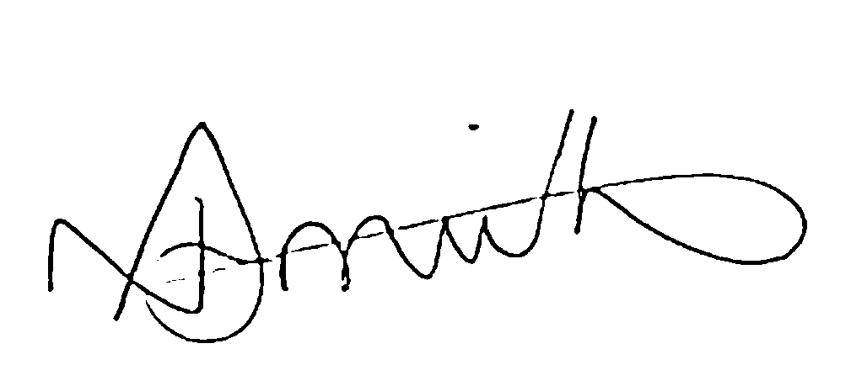________________________________________ Dated:____12/06/20_____________

ACT Guidelines  https://www.covid19.act.gov.au/resources/canberra-recovery-plan  https://www.covid19.act.gov.au/resources | NSW Guidelines  https://www.health.nsw.gov.au/Infectious/covid-19/pages/resources.aspx https://www.nsw.gov.au/media-releases/further-restrictions-to-ease-on-saturday

RISK RATING
Inherent - 4
Residual risk - 6

LIKELIHOOD: How likely is it that it will occur? | CONSEQUENCES: How severely could it hurt someone?
LIKELIHOOD: How likely is it that it will occur? | CHART EXTREME  Death, permanent disablement | MAJOR  Serious bodily injury | MODERATE  Casualty treatment | MINOR  First aid only
VERY HIGH  Could happen frequently | 1 | 2 | 3 | 4
HIGH  Could happen occasionally | 2 | 3 | 4 | 5
MEDIUM  Could happen, but rare | 3 | 4 | 5 | 6
LOW  Could happen, probably never will | 4 | 5 | 6 | 7

Score | Action
1, 2 or 3 | Do something about these risks immediately
4 or 5 | Do something about these risks as soon as possible
6 or 7 | These risks may not need immediate attention

