Resumption of Club Rally Days Phase 2 Risk Assessment.
In line with the AIS National Principals for Sport and Recreation Activities and Office of Sport NSW Recovery Group framework PCA NSW commenced Phase 1 resumption on the 22 May 2020. PCA NSW need to remain vigilant as we do not want our sport and any club or area to become the next COVID-19 cluster.
After the success of Phase 1 (Level A in the AIS Covid Safety Plan) PCA NSW in line with the AIS National Principles for Sport and Recreation and Office of Sport NSW Recover framework recommends the implementation of Phase 2 (Level B in the AIS Covid Safety Plan) from the 13 June 2020. Clubs will need to continue to ensure that all NSW Public Health Orders are adhered to. Clubs may hold extend their training/rally days however riders may not camp overnight and if Clubs decide to resume the use of a canteen strict bio-security and food handling procedures must be followed.
Full details on the Public Health Orders and restrictions can be found:
nsw.gov.au/covid-19/what-you-can-and-cant-do-under-rules
Please be aware that these are valid as of the 13th June 2020 and may change therefore you will need to continue to monitor the situation via NSW Premier media releases, Public Health Orders, Office of Sport, or PCA NSW website.
Mandatory items:
- Appoint a Covid Safety Coordinator
- Complete a risk assessment and send copy to the PCA NSW office
- Complete a Covid Safety Plan
- Complete resumption of sport checklist
- Ensure records are kept of everyone who attends pony club activities and events (recommend the use of Covid Self-declaration form)
Phase 3 (Level C in the AIS Covid Safety Plan) will commence on the 1st July 2020, restrictions will ease again and community competitions may be held at all levels – club, zone and state with restrictions as defined by the NSW Public Health Orders. Clubs need to keep updated Covid Safety Plans for Phase 3 and monitor the NSW Public Health Orders for any changes.
Mandatory items as per Phase 2 will still apply.
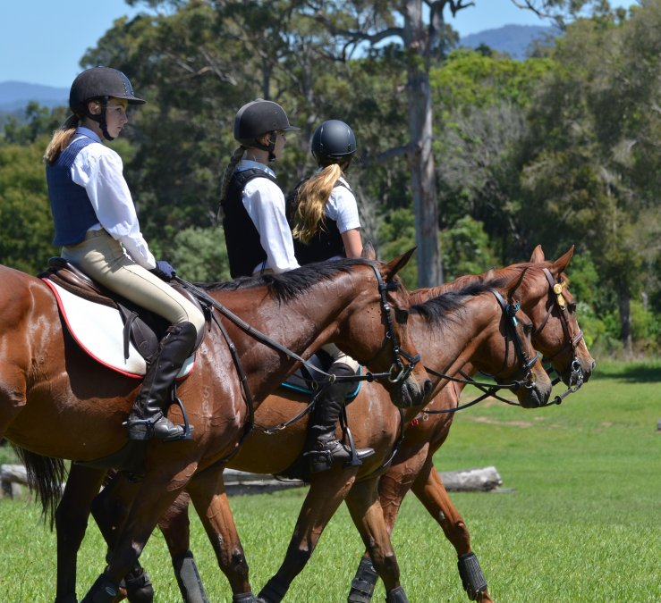
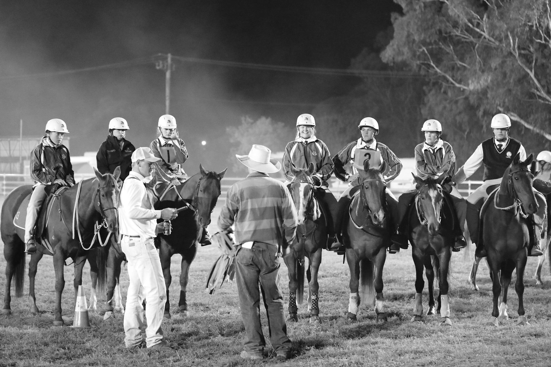
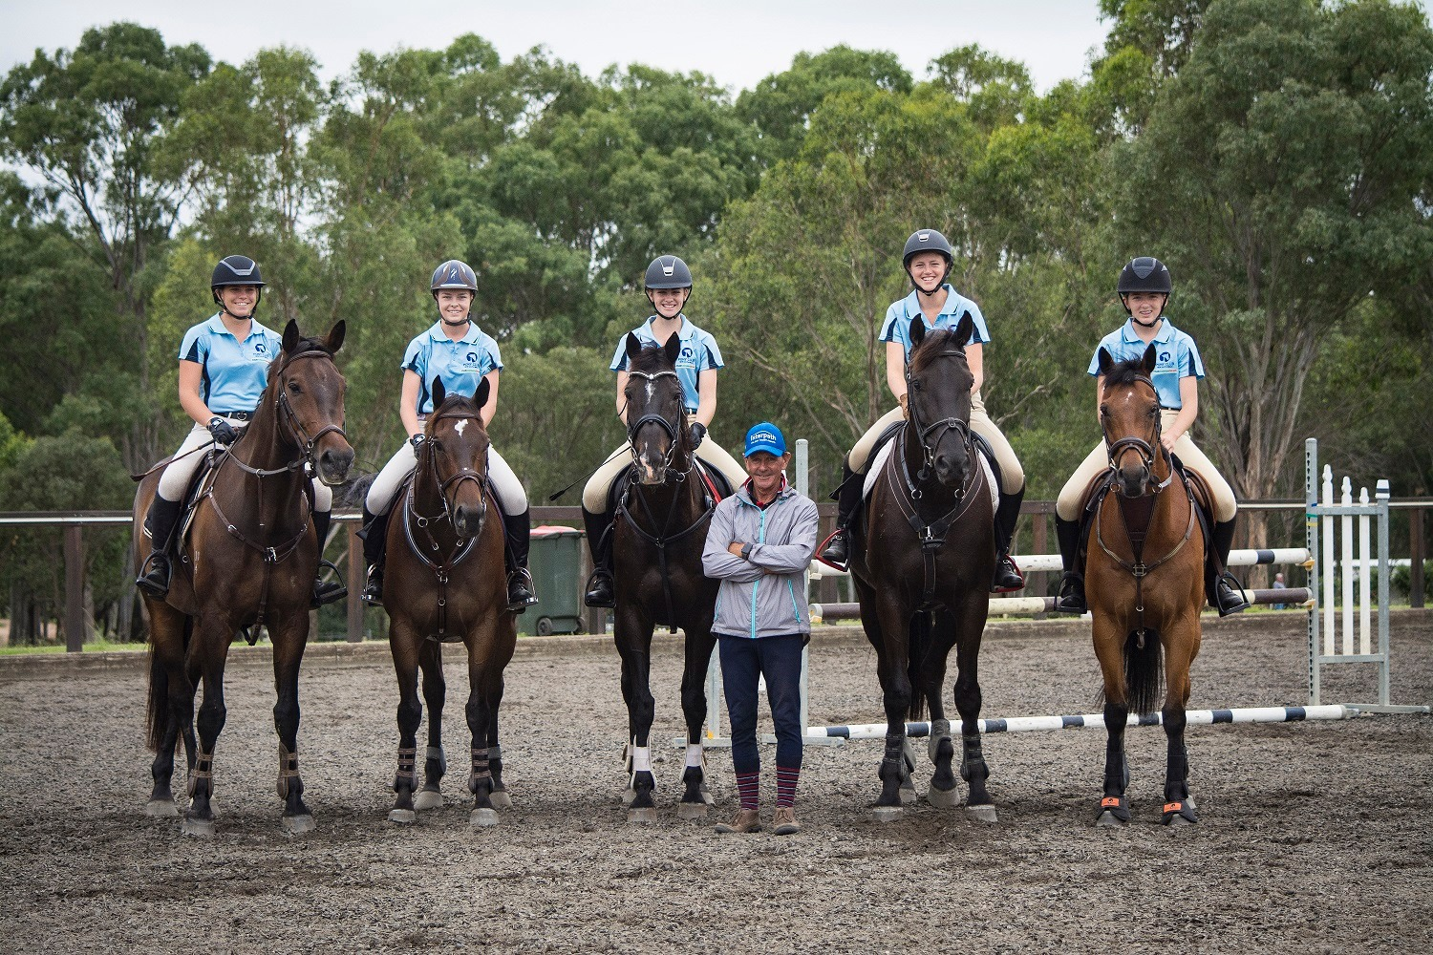
Club Training Rally Days Phase 2 Risk Assessment commencing 13 June 2020.
Date of Event: ______________________ |  | Risk Management Team: ________________ Pony Club | Covid Safety Coordinator: _______________________________
Risk | Risk Rating | Control / Actions | Person Responsible
Outbreak of Covid-19 | 3 | Appointing a Covid Safety Coordinator to ensure that everyone attending comply with the Covid Safe guidelines provided under the Public Health Orders, send copies of  - Venue Risk Assessment,  - Covid Safety Plan and  - Details of nominated Covid Safety Coordinator to the State Office | Organising Committee
Attendees to confirm and sign Covid-19 declaration which states that they are well and have not had contact with anyone with COVID-19 | 1 | If rider and/or family members have been to Covid-19 affected areas, or been in contact with someone who has Covid-19 or shows symptoms of Covid-19 they may not attend and need to self-isolate for 14 days and unable to attend pony club until signed off by Doctor with a negative Covid-19 test result. | Self-monitoring and if necessary self-isolate– members must determine their own level of risk depending and their current health status
Contracting Covid-19 during travel to event – driving | 4 | Ensure that riders follow all guidelines produced by NSW Health on how to protect yourself – see NSW Health website and recommendations below. | Self-monitoring – members must determine their own level of risk depending and their current health status
Contracting Covid-19 – whilst at Pony Club | 4 | - PCA NSW have strict bio-security protocols in place for both riders and horses.  - Riders to follow all directions of Organising Committee  - Organising Committee will ensure that the venue has been cleaned prior to commencement maintained during the event  - Organising Committee to provide washing facilities and/or 60% alcohol based hand sanitizer  - Rider and other attendees to regularly wash hands/use hand sanitizer and social distance as per NSW Health regulations  - Riders and other attendees to follow all guidelines produced by NSW Heath on how to protect yourself – see below | - Covid Safety Coordinator  - Organising Committee to oversee cleaning crews prior and during the event.  - Organising Committee to ensure that washing facilities are stocked with plenty of liquid soap and paper towel for all attendees  - Organising Committee to monitor hand sanitizer if being used to ensure that there is enough on hand  - Self-monitoring – members must determine their own level of risk depending and their current health status
If rider has concerns of possible contraction of Covid-19 | 2 | Follow NSW Health update on how the virus is spread and how long does Covid-19 last on surfaces - riders should follow all directions of Organising Committees and follow all guidelines produced by NSW Heath on how to protect yourself – see recommendations below. | Self-monitoring – members must determine their own level of risk depending and their current health status
Gear Check – no contact to be made | 2 | - No contact by Gear Check Steward to rider or their equipment during Gear Check  - Rider (if old enough) or parent/responsible person to be on hand (one per rider only) during Gear Check to make any adjustments to gear as requested by Gear Check Steward | - Covid Safety Coordinator  - Gear Check Steward  - Rider  - Parent/responsible adult
Contact between Instructors and rider – no contact to be made | 2 | - No contact by Instructor to rider or their horse during Regional School.  - Parent and/or responsible adult to be on hand (one per rider only) to aid if needed. | - Covid Safety Coordinator  - Instructor  - Organising Committee  - Parent/responsible adult
Contact between riders whilst mounted– no contact to be made | 2 | - Group numbers to be limited to so that the number of people on the ground or in a specified area do not exceed a total of 20 overall, who should be distanced accordingly to minimise the risk of contact from rider to rider whilst mounted.  - Riders to be advised that contact to be avoided both while mounted and unmounted  - Riders may need to be scheduled depending on the availability of instructors available for rally days.  - Groups of riders under instruction should not exceed reasonable instructor to rider guidelines at any time.  - Riders may still be limited to one adult/responsible person with them to maintain overall numbers.  - The number of riders per age group for competitions may be limited to ensure that overall numbers are not exceeded at each venue. | - Covid Safety Coordinator  - Instructor  - Organising Committee  - Parent/responsible adult
Response to fall of a rider | 3 | - The Organising Committee should appoint a dedicated First Aid person for the event  - The only people who may contact or respond to a fallen rider is the dedicated First Aid person or their parent/responsible adult  - All normal procedures regarding First Aid to be taken  - First Aider to always wear all appropriate PPE including mask and gloves  - Dedicated First Aider or another person authorised to act on their behalf should call an ambulance if necessary – please ensure that only one person calls, and that person has venue and patient details and information needed to help guide the ambulance to the venue | - Covid Safety Coordinator  - Organising Committee  - Dedicated First Aider  - Parent/responsible adult
Parking, catering, use of facilities by people attending Regional School | 2 | - Communicate with members to advise expectations at rally days  - Submitting self-screening forms  - Follow directions  - Determine who will speak people showing symptoms of COVID-19  - Vehicles spaces to be allocated with plenty of space between each vehicle  - Possible need for separate entry and exit points  - Riders to bring own food and drink with no sharing of food or drink between riders or others on the grounds  - Riders need to be ready to ride other than gear check so that they are not on the grounds longer than needed for scheduling purposes  - All persons on grounds to adhere to strict social distancing guidelines 1.5m between people as detailed below  - All persons on grounds to follow strict hygiene and hand washing procedures as detailed below  - Who will open and close gates – will need to schedule/allocate someone?  - Who will oversee taps – turning on and off etc. – or what PPE will be provided for people to clean as used  - Who will oversee cleaning of toilets or will people be tasked with cleaning themselves once used and who will provide the cleaning equipment etc. (club or member) | - Covid Safety Coordinator  - Instructor  - Organising Committee  - Parent/responsible adult
Instructor travel and accommodation | 2 | - Where possible local Instructors to be used to limit travel and associated risks  - Where possible local Instructors to be used to limit accommodation needs, if accommodation needed ensure that accommodation is withing restrictions | - Covid Safety Coordinator  - Instructor  - Organising Committee
Venue Specific concerns – please list details here as necessary |  | List items that are specific to your club here/use as many pages as necessary | - Covid Safety Coordinator  - Organising Committee

Signed: __________________________________________ Dated:_________________
Signed: __________________________________________ Dated:_________________

Protect yourself
The best way to protect yourself from COVID-19 is the same way you would protect yourself from catching flu or other respiratory illness:
- wash your hands for at least 20 seconds with soap and water or use an alcohol-based sanitiser with at least 60% alcohol.
- cover your sneeze or cough with your elbow or with tissue.
- avoid close contact with people who are ill
- avoid touching your eyes, nose and mouth
- stay home if you are sick.
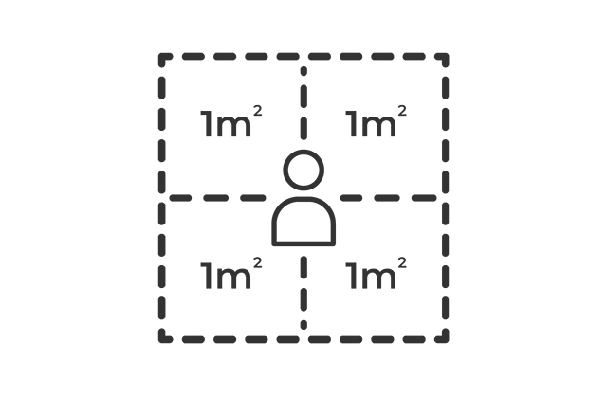
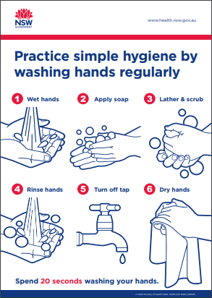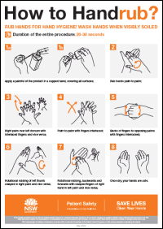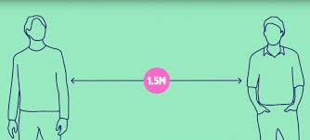
The 4 square metre rule helps to determine the maximum number of people allowed on the premises or attending an event. It does not determine the distance between people.
Physical distancing means reducing the close physical contact we have with one another and staying 1.5 metres away from people we don't live with.
Allow 1 person per 4 square metres
Call the National Coronavirus Health Information line 1800 020 080
For more information visit the NSW Health Website​.

