Queanbeyan Pony Club APPROVED 10 June 2020
Rally Day COVID Safe Checklist

As a committee all actions have been considered and mitigation strategies put in place cognisant of ACT Health guidelines and ACT Government Covid restrictions in addition to PCANSW recommendations.
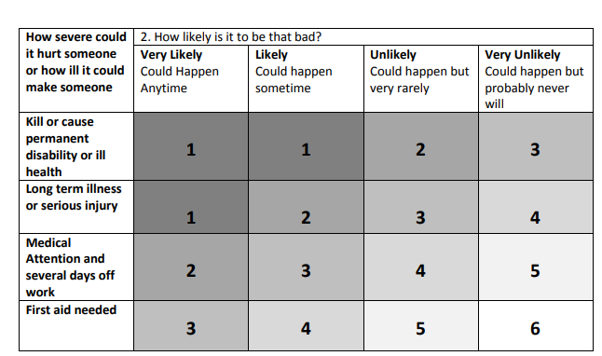
Inherent risk – rally day = 3
Residual Risk – rally day = 5

Supporting Documents
- Attendance register (expected and actual)
- Health declarations
- Program
- Riding group allocations and volunteer register
- Grounds map
- Safety Briefing
- Member Communication
- PCANSW covid checklist

Item | Action | Assigned to | Status / Comments
Before the day | - Confirm location – Tom asked to confirm if QPC can access paddock area  - Rally day notice to include all information, reminder to stay away if unwell and must advise all attending not just rider, COVID safe app recommendation, no canteen (food or drink available) and start finish times  - All attendees are required to pre register (includes everyone not just riders ) – needed by Wednesday prior to rally day via email and or Facebook  Advise members of:  - Map for circulation / parking etc  - All floats to enter on paddock side of the shed, all traffic must be one-way. This is so that health declaration forms can be collected on arrival. No form, no exit from car  - Shed including kitchenette is closed  - Toilet is available  - All participants required to complete health declaration and submit on arrival  - All attendees advised of requirements for Health Declaration submission etc  - Identify instructors for the day  - Groups to be identified and made known to riders prior to rally day, generally on the Friday prior  - No membership no ride! (day membership ok)  - Need to print documents in advance for come try day | Secretary  Chief Instructor  Membership Officer | Complete – Tom ok to host at his place
On the Day | - Back up plan if any official unwell and if someone unwell to be communicated to all organising the rally as soon as practicable  - If wet weather, no rally  - Gear check (no contact)  - Parent/ rider to address gear issues gear check (touchless) at session  - Groups go straight to activity  - Each instructor to give rally day briefing – set template to be provided by CI by the Friday prior  - Health declarations collected on arrival no form no entry and self temperature checks as part of declaration (PPE for collection volunteer)  - Pre rally, during and post cleaning of bathrooms  - Rally days structured with limited changes allowed  - Max 10 for each session includes parents, riders, coaches etc (recommend 5 riders, plus coach and up to 4 parents/ helpers per group)  - Riders stay in allocated group, no switching | Committee members & Instructors  Instructors  Safety Officer  Chief Instructor | Hand sanitiser and or gloves to be made available
Location / ground | If at Tom’s:  - Identify single point of access and one way circulation  - Entry gates  - Someone at the gates at all times, need to limit the number of times gates are handled  - Hand sanitiser and gloves available at each gate  Advise members of:  - Map for circulation / parking etc  - All floats to enter on paddock entry to shed area – i.e. one-way circuit – to assist collection of health declarations  - Shed including kitchenette is closed  - Toilet is available  - All participants required to complete health declaration and supply on arrival | Secretary | Soap, hand sanitiser and or gloves to be available
Equipment | - Allocate volunteers to equipment set up and reset  - All equipment cleaned pre, during and post (and during if relevant)  - Rally day plan to clearly articulate equipment, and aim to keep this at a minimum | Chief Instructor | Cleaning materials to be provided by Club
Signage | - Print, laminate and display COVID Safe signage  Cattle grid gate  Toilet  Taps / sink  Gate in to / out of the paddock  - Install signage for float parking (if needed) | Safety Officer | Signage type / message to come from the PCANSW site x 8-10 units, A3 minimum – member has indicated will print at own expense  Existing corflute signs can be used to direct members
Sessions | - No riding in pairs/ fours / troop drill etc  - Sporting / MG/ games pretend hand overs no equipment 2 volunteers with PPE to support fixing equipment  - Jumping – 2 volunteers with PPE to support pole picking etc | Chief Instructor | Soap, hand sanitiser and or gloves to be available
First Aid | - Make sure the first aid kit is stocked and available | Safety Officer | Kit was replenished in January 2020  Do we need PPE
PPE & Cleaning equipment | Club to have available:  - Soap pumps  - Hand sanitiser  - Gloves  - Cleaning materials for equipment and designated spaces (eg toilets)  Members advised to provide:  - Hygiene / PPE as needed but suggest hand sanitiser as a minimum | Safety Officer  Secretary | Will require expenditure estimated at $120
Documentation | - Attendance register inclusive of all on grounds for each rally  - Health declarations for each person on the grounds (includes non-riders)  - Extra copies available at rally day  - Risk assessment to be undertaken and submitted to PCANSW | Membership Officer  Safety Officer | All documentation must be retained  Risk assessment to be undertaken by Chief Instructor and made available to all Committee members

